Revision

OPSC7311 (B) POE

Westville Campus

Karl Dicks – 17667327

Contents

Introduction 3

Task 1 Improvements 4

Task 2 Improvements 5

Conclusion 6

# Introduction

As part of our OPSC7311 project, we were tasked with researching three existing fitness trackers. The following information was provided in our Task 1 research document:

* Introduction
* Research of each fitness application, including:
  + Overview of the app;
  + Strengths and weaknesses of the app;
  + Innovative features of the app;
  + Screenshots of the app;
* A comparison of all three apps;
* A list of the best features of all the apps that you want to use in your final app;
* Conclusion;
* References.

The three applications which I assessed in my research document were:

* Accupedo Pedometer
* Samsung Health
* Pedometer Step Counter

Once the research document was completed, a design document was generated for our own application. This included the following information:

* Introduction;
* Brief overview of your app including the app’s innovative features;
* A list of functions, described in detail, that your app will perform;
* User interface design for each screen as well as navigation information between each screen;
* Detailed listing of the data that the app needs to capture from the user and store as well as how you will store this data;
* Project plan detailing deadlines and milestones for you project;
* Conclusion;
* References.

This information was used when developing our own fitness application.

For our POE submission, we were tasked with improving our Task 1 research document, and updating our design documentation. We were also tasked with improving our fitness application, and including additional features. Details of these two tasks are included in the following section.

# Task 1 Improvements

The following feedback was received for my Task 1 submission:

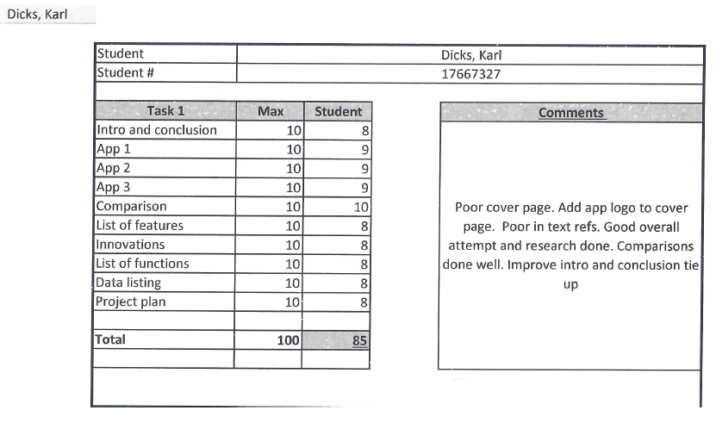

I have made the following changes to my Task 1 assignment:

* Cover page design updated.
* Application logo added to the cover page.
* Grammar corrected.
* Spelling mistakes corrected.
* Design document updated, including the following changes:
  + List of features updated.
  + Screenshots updated.
  + Screenshot descriptions updated.
  + Data listing updated.
  + Introduction and conclusion have been updated and improved.
  + Inclusion of additional features which have been implemented.
* In text references corrected (included in all sections).
* Figure numbers included for images.
* Introduction and conclusion for research document has been improved.
* Bibliography updated.

The above changes have been made to my Task 1 assignment, in order to update its content and improve it based on lecturer feedback.

# Task 2 Improvements

The following changes have been made to my Task 2 assignment (practical), in order to improve on the original design, and include required features for the POE submission:

* Step counting was implemented in my Task 2 submission; however, the application did not register steps when the phone screen was turned off, or the application was closed. This has been fixed, and it now counts steps when the phone is locked (screen is off), or the application is closed.
* Weight monitoring was implemented in my Task 2; however, weight loss progress was not. This has now been implemented on a pie chart, accessed from within the “Weight Monitoring” page. The user may view current weight, target, and weight loss on this chart.
* Debugging was completed, and the following three errors were fixed:
  + The user was able to crash the application when setting a null weight target in the goals page. The user is no longer able to set null weight targets, which has solved this issue.
  + When the weight target was not set, the user was able to crash the application when selecting the Metric / Imperial units switch in the “Weight Monitoring” page. This has issue has been fixed, by catching this error, and displaying a suitable message in the Target Weight label.
  + Weight monitoring would sometimes not order weights in the correct order (date descending). This has been fixed by correcting date input format.
* The application design has been improved, including:
  + Rounded button corners have been implemented.
  + Button text color has been changed.
  + Activity names (headings) have been fixed, as some were not set correctly.
  + Text spacing and font size was changed on some activities, in order to improve consistency.
  + Registration of the user account only completes once the user has filled out both the account and personal information pages.
  + Step count progress bar turns green once the user reaches their daily goal, rather than one step after their goal has been reached.
  + Included buttons to access added functionality.
  + Included new functionality.
* Demo video updated to include additional functionality and improvements.
* Documentation updated.

# Conclusion

In conclusion, the above-mentioned changes have been implemented in my Task 1 and Task 2 assignments, in order to improve their quality. Additional functionality has been included in the practical submission, in order to complete all required functionality in the POE question paper.

Debugging has also been carried out, in order to address application bugs and issues which were present in Task 2. These issues have since been resolved, and changes have been made for the final POE submission.